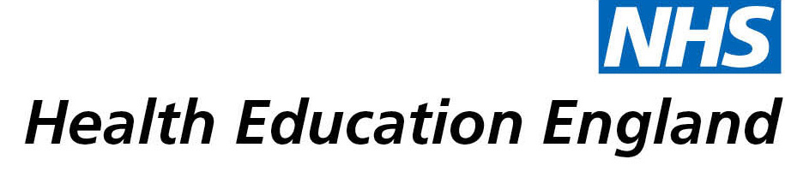

# Library and Knowledge Services case study

# Royal United Hospitals Bath NHS Foundation Trust*:* Revision of hand therapy protocols

Date *[06/07/2021]*

Date of interview: 21/05/2021

## Reason for enquiry

With the advent of a paperlite Trust-wide initiative, the Hand Therapy team looked to moved all protocols and patient information to electronic format. This presented the opportunity to update all protocols to ensure they reflected current practice, whilst also remaining current and evidence-based.

The Academy Library was initially approached in Spring 2019 to feed into this process by providing the evidence to support the revisions.

## What the knowledge and library specialist did

Over a period of several months, searches were carried out by the Library using healthcare databases and information resources. This evidence was supplied to the department for each condition / procedure when requested eg carpal tunnel decompression, extensor tendon repair, MCPJ arthroplasty etc.

After the initial searches and revisions, six-monthly updates were put in place to ensure updates are ongoing as evidence and guidance changes.

# Impact of input from the library and knowledge service

* Twenty hand therapy protocols revised.
* In-service training to update team knowledge and practice ensuring consistency.
* Regular updates to maintain currency and aid service development.
* Enhanced patient outcomes who are receiving the most up-to-date interventions at the appropriate time.
* Progress is faster with less appointments needed for patients.
* Significant amount of clinical time saved by the Library carrying out the research
* Protocols shared with community partners and peripheral departments for patient rehabilitation.
* Electronic format provides ease of access for clinicians and patients.

## Immediate Impact

As information was received each hand therapy area was allocated to a member of the team of six, who collated the evidence to create the new standardised protocol and patient guidance. Each was then presented to the whole team, reviewed, revised and signed off. The process was speeded up as a result of the first COVID19 lockdown.

Team and personal knowledge increased via updating process.

Confidence increased for team and patients knowing that practice and guidance is up-to-date.

***“A big thank you to the library services team, for all of the help and time you have generously given”.***

***“It would have taken us at least twice as long to do the same searches probably taking several years to have completed them all, due to trying to find suitable blocks of time to fit this type of work in around our clinical work”***

## Probable future Impact

* Continue to keep up-to-date and evidence-based.
* Enable service development where appropriate.
* Continue to save clinician time via the Library updates.
* Increased patient adherence to guidance, which is key to recovery, due to ease of access (printed, email, phone) to clear and up-to-date information specific to their procedure or condition.
* New protocols will be created as new specialisms and services are coming on board in the near future with a new Hand Consultant joining the team.

***“Research underpins Hand Therapy at the RUH, enhancing patient experience and outcomes”.***

## Name and Job Title:

Name: **Mark Sheriff**

Job Title: Extended Scope Practitioner – Hand Therapy

## For further information on how you can get similar support contact your local NHS library and knowledge service.

**Submission Details**

**[To be completed by Knowledge and Library Service at the point of submission]**

Name of Organisation Royal United Hospitals Bath NHS Foundation Trust

Knowledge and Library Service Contact Email *lisa.hirst2@nhs.net*

NHS Region South West

Title of Case Study *[****Revision of hand therapy protocols****]*

Sector Acute

Group Impacted Multiprofessional

Impact Types [Please select any which apply]

Contributed to personal or professional development.

Contributed to service development or delivery.

Facilitated collaborative working.

Health Information for Patients, Carers and the Public.

Improved the quality of patient care.

Mobilising evidence and organisational knowledge.

More informed decision making.

Productivity and efficiency.

Reduced risk or improved safety.

Saved money or contributed to financial effectiveness.

Improved health and wellbeing of staff and learners

I have consent from individuals referred to in this case study to share details nationally for advocacy and promotion.

Yes